G Hogg

Working with Veterans

HMP Kirklevington Grange

Kirklevington is an Open/Resettlement establishment, and in that context much of what I will speak about was intended to raise the self-esteem of Veterans who were due for release into the community, and to give them some positive experiences to speak about with prospective employers.

The start
I was approached by my Deputy Governor asking me be the lead for Veterans in Custody Support (ViCS) at HMP Kirklevington Grange.

I knew little about ViCS, the only qualifying criteria for my ‘selection’ was that I had previously served in the Her Majesties Relaxed Air Force from 1980 to 1986 but largely the fact that we are a small establishment and choice was limited amongst managers.

I was vaguely aware that we had a veterans group so there was obviously some work to be done promoting the profile.

Initially, I tried to think of it from a Veterans perspective i.e.

- Why would I want to be identified as a veteran?

- How could ViCS benefit me?

If I could answer that, then I could get prisoners on board.

I spoke to a few Veterans on a casual basis and it was obvious that they were proud of their service, that it had been a high point in their lives and where they had felt most relevant.

I saw this information as the key to having a successful outcome.

ViCS had to make them feel “Relevant” again

ViCS Meetings
Upon investigation of the current arrangements I quickly became aware that there was a lack of purpose or direction in the group and little engagement from the sparse number of veterans who attended the quarterly meetings.

It had become a ‘knitting circle’ for a few regulars, no agenda, just chatting and reminiscing, which, was pleasant and affable enough...

BUT enough, did not actually achieve anything, if I was going to take a more proactive role, then this needed to change.

I was extremely fortunate to have a committed Operational Support Grade who was keen to be involved in this work.

However he had very limited time available from his normal duties and also has serious domestic issues to contend with which required the rest of his attention.

- Identified Problems – Low ViCS profile, limited staff time and availability, limited engagement.

So to get the ball rolling, I issued notices around the establishment and sent letters to each prisoner inviting them to the next scheduled meeting.

I came up with a draft agenda for the meeting but left it open to adjustments or recommendations from those who would hopefully attend.

I wanted the chaps to ‘buy in’ to the proposed changes I wanted to make, this would only happen if they had input, otherwise I risked disengagement from the start.

Happily I must have struck the right note with my poster/letters, as there was a significant turn out of veterans (25+) at the next meeting.

This also included some whom I did not know were veterans and who were not recorded as such on the NOMIS system.

I made sure I had a register of attendees and following the meeting, I and my staff collated the required information of service from each individual to check against NOMIS accuracy and to make new entries for any missing data.

Event 1
I was fortunate to be assisted by our new RC Chaplain Neil Galloway, himself ex-RAF (25 years) and who was very keen to get involved with the Veterans.
Neil had fairly recently left the RAF having been stationed at RAF Leeming, coincidentally this being the first station to which I was posted when I joined the RAF.
This base was only a relatively short distance from HMP Kirklevington Grange, and we made enquires in respect of work which could be done by veteran prisoners at RAF Leeming.
We considered what skills the prisoners had acquired, both previously and at Kirklevington and how we could use these to support the military base.
I hoped to be able use this connection to give the veterans a fresh taste of military life, as it had been obvious from the meeting that there was a significant thirst for such a connection.
Following our enquiries, we visited the base on several occasions, meeting with the ‘Families Officer’ and the RAF Chaplain, whom we also invited to the prison to show what we could offer, then we asked them to send us a wish list to see what we could do reasonably achieve.
After much discussion and assurance, and meetings with a variety of service personnel we eventually did the following work at RAF Leeming over a period of some months.
- Redecoration/refurbishment of the Chapel

- Redecoration/refurbishment of the ‘Hive’ families building

- Redecoration/refurbishment of the Youth club

- Redecoration/refurbishment of the Junior ranks club

All of the above were very well received by the RAF (who supplied all the required materials) and enthusiastically undertaken by the veterans involved.
They enjoyed the experiences, being in the company of serving service personnel, exchanging stories and the opportunity to become re-acquainted in a limited extent with day to day military life.
This really invigorated the veterans to remain engaged and motivated.
The facility for prisoners to be spreading the word within the establishment about what we were doing was far and above what I could have hoped to achieve by publishing the information myself.
We had further plans to open a white goods repair shop on the base, and had identified a building, and had it wired for electricity and plumbed for water.
Unfortunately however this was eventually scuppered following Trades Union involvement who did not want their members having to mix with prisoners.
This was disappointing but not the end of our involvement with RAF Leeming.

Event 2
My ongoing discussions with Rev Galloway disclosed that he had, during his time in the RAF, organised commemorative ‘Long March’s’. (Details on the Internet/ and Intranet)
- Short version - 60 miles marched over 3 days in the community by a joint team of prisoners both Veterans and non-Veterans, Prison Officers and serving RAF Regiment personnel - Result - £4k raised for local and National charities over 2013 and 2014.

In late 2013, local papers published the pictures of the handover of a cheque to ‘Combat Stress’ from our charity event which has led to involvement in other activities.
Between 2013 and 2014 the ViCS raised over £4k for charity.

In late 2013, local papers published the pictures of the handover of a cheque to ‘Combat Stress’ from our charity event.
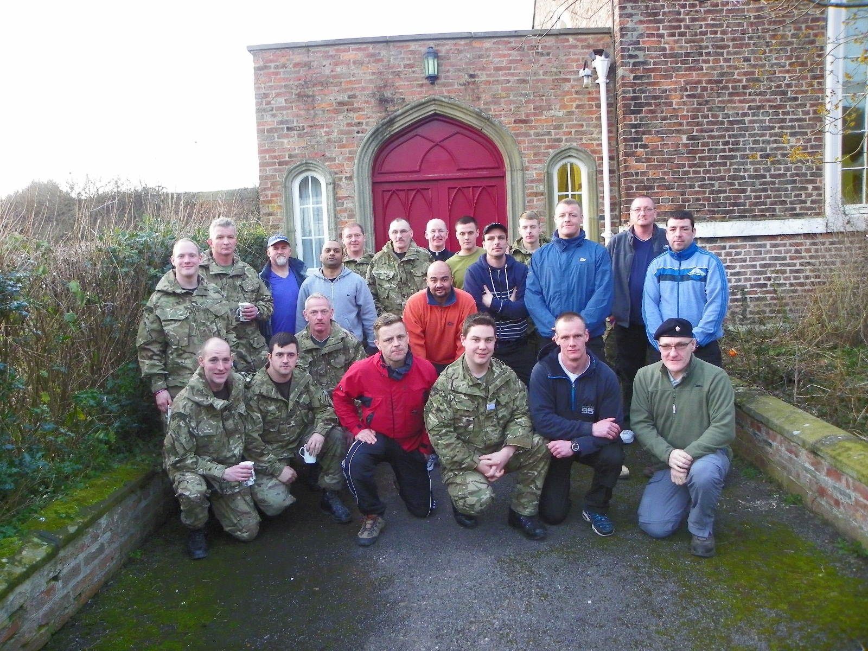

Event 3
Having seen our picture in the paper, I was then approached by the Mayor of Yarm with a view to involvement of prisoners, predominantly but not exclusively veterans to be involved with the following year’s centennial anniversary of the commencement of WW1.

After further details were obtained and with my Governors approval I again I raised this at one of our regular ViCS meetings and was inundated with volunteers.

As I already had planned another long march in 2014, I made sure to have less able bodied veterans involved in these proposed activities.

This was achieved with some of my older veterans being involved in less strenuous activities both in the preparation of and assisting at Remembrance services.

The more fit vets assisted in the erection of a mock ‘trench’ to aid the public to visualise the WW1 experience at a local ‘WW1 event’ and the less fit in less strenuous activities associated with the event which included staffing stalls, leaflet issue, general assitance etc.

Actions
I have made a list of ‘essential’ actions which I consider will have a positive effect and make your life a lot easier in respect of working with veterans…
This is by no means an exhaustive list but will be a good starting point.
- Get a copy of the document ‘Working with Veterans in Custody’ (and read it).

- Ensure raising profile of ViCS is your first priority, if no-one knows about it then you are on the back foot immediately.

- There is a tangible genuine ‘thirst’ from veterans to maintain meaningful links with the military, use that to your advantage.

- Prisoner veterans are both proud of their previous service in the military and conversely usually embarrassed with their position as a serving prisoner and are consequently very willing engage in activities which will (in their view) mitigate that perception of themselves.

- Publish details of the availability of Veterans badges and make an issue of presenting them, see if the Governor or a Governor with military service will present the badges i.e. make a fuss of them.

- Remain open to what the veterans also want to achieve from the group, listen to their comments and be prepared to make changes to your views or targets, that way they should remain engaged and you will be in receipt of a range of ideas.

- You need committed staff who have the time, interest and capacity to work with veterans, however it is too easy to load up one person with this task, so ensure you have a minimum of a couple of staff to help share the work and knowledge (to cover nights/leave).

- Get an agreement from your Governor to have this work added to both your own and their SPDRs, that way if you or others cannot find time to do the ViCS work the Line managers can be brought in to argue with the detail.

- Make sure that the priorities are emphasised at the veterans meetings from the outset i.e. employment, training, education and housing.

- If these basic requirements are being addressed and engaged with, then consideration for wider ‘extra-curricular’ activities can be undertaken.

- Have a specific ViCS Noticeboard

- Publish details of the ViCS team, photographs

- Use the induction process to capture the required Nomis data, plus ask the Veterans to bring to your attention any new prisoners who are veterans but who may not have been ‘data captured’.

- Take a register at each ViCS meeting so you can track engagement, attendance and identify any drop outs.

- If possible get a Veteran to be involved in the induction process at some point to promote the group, or get ViCS to be included in the induction information.

- Ensure referral to mental Health services if not already done so if suspicion or concerns regarding PTSD/Mental Health issues etc. Once you gain their trust other Veterans will contact you to flag up issues with their peers which staff may have missed.

- Do you have any staff at you establishment who have military connections or links to the military, they can be a valuable resource when organising fund raising.

- Shamelessly exploit any and every contact with the military however tenuous, they are likely to have other local contacts who will be extremely keen to be seen to be supporting veterans, plus they will have ideas and facilities which you can also tap into.

- Look at your local area, what military establishments are close by (They will be keen to support ‘unfortunate’ veterans)

- What size of establishment is it, is there a large contingent of staff, if so then they will have a considerable resources but like ourselves be subject to tight budget controls and will very likely to be very happy to consider a ‘mutual benefit’ relationship.

- What industries does your establishment have, how could services be supplied to them in exchange for support i.e. White Goods repair, PAT Testing?

- What charities are specifically supported by the base, could you organise an event to support them, (this will be especially well received), if you do raise funds, try and take a veteran with you to hand over any cheques.

- Make contact with the base Chaplain to facilitate introductions to other ‘functional heads’ on the base.

- Use google to search out local military affiliated organisations and charities and get an invitation to meet and find out what they do, what they can do for you.

- Network with local military affiliated groups, i.e. we have the Sunderland Armed Forces network whose meetings I have attended (Other military affiliated organisations such as SSAFA, RAFA etc are available).

- Get ‘business cards’ made which identifies your involvement with veterans and distribute these freely with contacts and at external meetings.
- Use google to search out local military affiliated organisations and charities and get an invitation to meet and find out what they do, what they can do for you.

- Register as a fundraiser for H4H and the British Legion, and get permission from the Governor to sell Wristbands and Poppies etc to both staff and prisoners (This will open further doors).

- Consider guest speakers with military experiences, these are very well received and can be used to motivate the veterans.

- If you can’t take your prisoners into the community, what can be done in the jail i.e. our welding workshop produced metal stands for ceramic poppies for the local remembrance ceremonies.

- Do not exclude non-veterans from ‘military themed’ activities (after having given the veterans first bite of the apple) as this bolsters the Veterans self-esteem that other prisoners want to emulate them.

- Consider a ‘Veterans against Civvies’ gym team competition. (ICFT – Infantry Combat Fitness Tests).

- Be ‘creative’ in your thinking and push the boundaries in what you want to achieve.

- Activities also need to cater to those who are not only young and fit, but also those who may be older and physically frail and therefore we should seek out or suggest additional events and activities which are not exclusively for ‘gym bunnies’…ask those who may be suitable what they may want to do?

- There are a significant number of events for service leavers to gain employment i.e. Local Jobs fairs which specifically targeted servicemen/women and for which your veterans could apply to go to if eligible for Release on Temporary Licence.

- Information with regard to these events can be gained from either Google, Veterans Associations/Charities or from military bases themselves.

- We are all aware of the large number of service ‘redundancies’ however we can also use that which is available for current leavers as it is equally applicable to ‘our’ veterans.

- Make contact with your local Regular Forces Employment Agency representative – very useful contact.

- Find out who your ‘Shelter’ representative is for the establishment, they will have contacts in respect of accommodation specifically for ex-servicemen/women

- Be very cautious of getting your veterans hopes up regarding training places aimed specifically at veterans, there are some who promise a lot and deliver little, get peer referrals or feedback from previous clients if possible, they should be happy to provide this.

- Publish your successes in local media (Radio and Papers), and on the intranet, this will lead to further opportunities to raise the Veterans/ViCS profile and to undertake extra work with them.

- Don’t let disappointments stop you from pursuing future projects with the same partner, if you get despondent then this will quickly be picked up on by Veterans

